Minh Nguyen

CS 225: Quiz over week 9 Material

1) A biologist can use an undirected graph to study how pairs of gorillas exhibit hostility towards each other. Each gorilla population can be represented as a vertex and where an edge starts from one gorilla, a, to another gorilla, b, if there is hostility between the two populations of gorillas. There is a possibility that this could be a directed graph as well, where only one group a, shows hostility towards a more passive group, b. Unlikely, but is still possible.

2) The set of people can be modeled as an undirected graph G(V,E) where each person is represented by a vertex, and where two people, a and b, are connected by an edge if they are mutual friends. Then the number of a person V who has mutual friends is the degree of V. Then the sum of people with mutual friends is equal to $\sum_{v £V}{deg⁡(v)}$. According to the handshaking theorem then, $\sum_{v £V}{deg⁡(v)}$-2e, where e is the number of edges on the graph. So the sum of across all individuals of their mutual friends must be an even number.

3) a 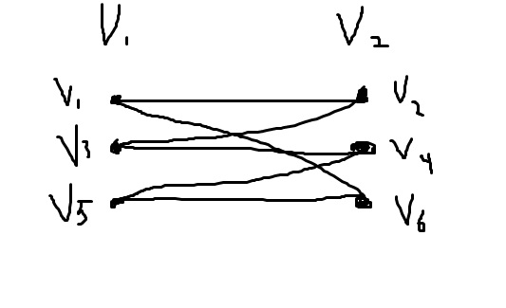

This is a graph with 6 vertices and is bipartite. It is bipartite because its vertex set is the union of two disjoint sets (v1,v3,v5) and (v2,v4,v6). and each edge connects a vertex in one of these subsets to a vertex of the other subset, but each set themselves are never connected directly.

b) 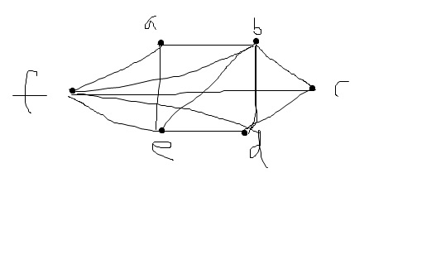

Here is a graph with 6 vertices that is not a bipartite graph. It's not bipartite because its vertex set cannot be partitioned into two subsets so that the edges do not connect two vertices from the same subset.

4) This question can be proven in two ways, both allowing G to be bipartite, and G to not be bipartite. The question asks to prove that G is not a bipartite graph. A graph is bipartite if and only if it is possible to assign one of two different colors to each vertex of the graph so that no two adjacent vertices are assigned the same color. Consider a graph with 3 vertices, and that each vertices are connected with each other by an edge. This is essentially a triangle. This is a case in which at least one vertex is connected with every other vertex by an edge, and is still not a bipartite.

On the other hand, G could be a bipartite if you remove one of the edges , and at least one vertex will still be connected to all other vertices via an edge.

5)a) yes, A graph can have both an Euler circuit and an Euler graph. An Euler circuit can only exist if every has an even degree. A Euler path cannot exist if it has 2 or more vertices of odd degrees. So an Euler circuit is an Euler path, but an Euler path cannot be an Euler circuit.

b) 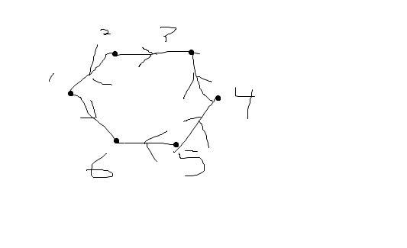directed weakly but not strongly connected graph.